International University
School of Electrical Engineering

Course Name
Course ID

Lab Title

Submitted by
Team leader [Your name and Your ID number here]
Member: [Your name and Your ID number here]
Member: [Your name and Your ID number here]

Date Performed: [insert date]
Date Submitted: [insert date]
Lab Section: Lab 1
Course Instructor: M. Eng Nguyen Minh Thien

GRADING CHECKLIST

Number | Content | Satisfied? | Score | Comment
1 | Format (max 10%)
 | - Font type | Yes No
 | - Font size | Yes No
 | - Lab title | Yes No
 | - Page number | Yes No
 | - Table of contents | Yes No
 | - Header/Footer | Yes No
 | - List of figures (if exists) | Yes No
 | - List of tables (if exists) | Yes No
 | - Lab report structure | Yes No
2 | English Grammar and Spelling (max 10%)
 | - Grammar | Yes No
 | - Spelling | Yes No
3 | Team Contribution Table (max 10%)
4 | Data and Result Analysis (max 70%)
Total Score

Date:

Signature

TEAM CONTRIBUTION

Task | [Team leader] | [Student 2] | [Student 3 if any]
Collaboration | Organize workload | Proofread report | Proofread report, coordinate tasks…
Lab preparation and experiment | Set up equipment, test the circuits,  Answer in-class questions | Gather components, build the circuits,  Answer in-class questions | Record data, test the circuits  Answer in-class questions
Data analysis | Perform calculation | Perform simulations | Interpret and compare results
Report writing | Write fundamental background | Write experiment procedure | Write results and conclusion/discussion

Table of Contents

List of Figures ........................................................................................….….............................. 3
List of Tables .................................................................................................……....................... 3
Discussion of Fundamentals.............................................................................................…….... 4
Experimental Procedure.............................................................................................……........... 4
Results ........................................................................................................……... 4
Conclusions………...................................................................................................................... 4
List of Figures
Figure 1 – ………………………….……...…………………………………………………… x
Figure 2 – …………………………………………………………………..……………...….. x
Figure 3 – ……………………………………………………………………………………... x
Figure 4 –………………………………………….………………………..……………...….. x
Figure 5 – ……………………………………………………………………………………... x
Figure 6 – ……………............................................................................................................... x

List of Tables
Table 1 – ……………………………………..……………………........................................... x
Table 2 – ……………………………………..……………………........................................... x
Table 3 – ……………………………………..……………………........................................... x

Discussion of Fundamentals
In this section, describe the fundamental knowledge of the topic in this lab section. For example:
If Selection Statement

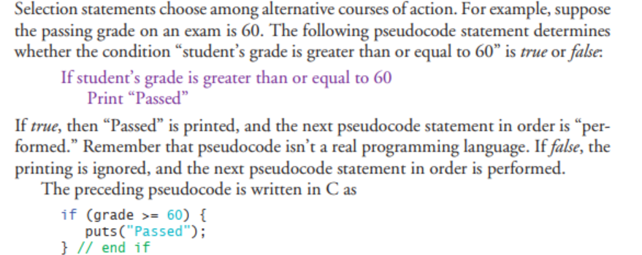

Experimental Procedure
Describe your problems here. Then, you should use flow chart or pseudo code to show your solution.

Experimental Results
In this section, you will paste your codes and the results here. The code section should be clean, easy to read, font type Consolas, size 10. For example:
Problem 1:

#include <stdio.h>

int main(void)
{
//Variables decleration
int num1, rem1;

//Input processing
printf("Input an integer : ");
scanf("%d", &num1);

//Processing
rem1 = num1 % 2;

//Output Processing
if (rem1 == 0)
printf("%d is an even integer\n", num1);
else
printf("%d is an odd integer\n", num1);

}

Result
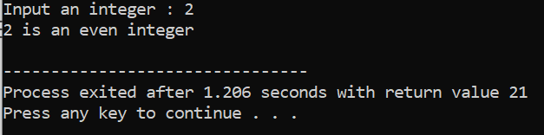
Figure 1. Result of the program in Problem 1 – Even/odd number checking.

Conclusion
In the discussion, you should summarize your work in this lab.
Discuss the difficulties you have coped with and how you overcome them.
Emphasize and discuss the points that you consider to be important in this lab.

THE END

